2023 NRPA Annual Conference Exhibitor Communications Toolkit
May 2023

About this Toolkit
Thanks so much for partnering with us as an exhibitor at our 2023 NRPA Annual Conference! We are so pleased you’re joining us on October 10-12. Attendees rate our Exhibit Hall as one of their favorite parts of the Conference year after year – and we’re excited about the great connections you’ll make during the event.

To help get the word out about the Exhibit Hall to your networks as well, we’ve put together a toolkit to make it easy for you and your communications team to share about the Conference. This toolkit includes:

Core Messaging 3
Messaging to Pull From 3
Social Media Resources and Recommendations 4
NRPA Handles 4
Hashtags 4
Important Link 5
Sample Posts 6
Social Media Best Practices 9
Social Media Videos 12
Graphics 13
Newsletter and Website Content 14
Media Relations Tips 15

If you have any questions, please reach out to Ruth at RWheeler@nrpa.org.

We’re looking forward to another great year!

Core Messaging
We are using the core messaging below in all our communications to build excitement about the NRPA Annual Conference. You’re welcome to use this messaging about the NRPA Annual Conference as well.

Research tells us that consistency and repetition matter when sharing about an event like the NRPA Annual Conference! Repeating strong messages can help you raise awareness about the event and your participation, and build interest in your offerings, too. The Marketing Rule of Seven tells us that your audience has to see a message seven times before it begins to resonate with them.

The core messaging ensures we are using the same, powerful messaging — with a clear call to action — in all of our materials.

- We’ve dropped the core messaging into this document below.
  - NRPA’s theme for the NRPA Annual Conference this year is “Where Community Grows.”
- These messages are based on what we know people value most about the NRPA Annual Conference.
- Please use these messages however is most useful for you! For example, you might pull just a line or two for social media, use more of the messaging to expand the website content, etc. You are also welcome to add in why you exhibit at the NRPA Annual Conference, how you feel about partnering with park and recreation professionals, etc.

Messaging to Pull From

Conference Overview
Park and recreation professionals like you are dedicated to building strong, healthy and resilient communities, every day. From directing your organization’s budget to managing exciting programs, you’re always looking for ways to serve your team and your community. By coming together to network with, learn from and celebrate each other, we can truly build places Where Community Grows.

- For more than 50 years, the NRPA Annual Conference has been the premier meeting of the park and recreation community. Sign up today to join thousands of professionals just like you who are passionate about finding new tools to help their communities grow and thrive.

Messaging About the Exhibit Hall
During the NRPA Annual Conference, attendees will experience inspirational education sessions, networking opportunities, celebrations and an inside look at the latest products for the field.

Colleagues, experts and top park and recreation product representatives are joining together in lively Dallas to:
- Find products and services to help solve everyday challenges. From full playgrounds to live software demonstrations, more than 400 partners and vendors are setting up booths and interactive exhibits at the Exhibit Hall!

Messaging About Additional Aspects of the Conference
Colleagues, experts and top park and recreation product representatives are joining together in lively Dallas to:
- Learn from people who get it. You will hear from people who experience the same challenges you do – and learn actionable solutions you can take back to your own community.
- Meet and enjoy networking together. The NRPA Annual Conference offers many opportunities to connect and help grow community with other professionals just like you.
- Earn CEUs! Whether you are striving towards a professional certification or building your personal knowledge base to better serve your community, NRPA offers hundreds of CEU sessions throughout the 2023 NRPA Annual Conference to help get you there. From entry-level courses to advanced learning opportunities, you will find exactly what you’re looking for through the tailored offerings.

Vision for Conference Attendees
After the 2023 NRPA Annual Conference, you will not just gain actionable new knowledge, but also feel energized, inspired, supported and ready to help your communities grow.

Social Media Resources and Recommendations
Social media is a powerful tool to let attendees know you’ll be in Dallas, showing them why they should stop by your booth and learn more about your organization! To make sharing easy, we’ve included:

- NRPA handles that you can tag while posting
- The NRPA Annual Conference hashtag to use
- Link to use when posting
- Sample social media posts you can easily update
- Social media best practices
- Tips about using videos

NRPA Handles
Tag us in your posts so we can engage with you and extend your reach!

- Facebook: @NationalRecreationandParkAssociation
- Twitter: @NRPA_news
- LinkedIn: @national-recreation-and-park-association
- Instagram: @nrpa

Hashtags
Hashtags help social media users easily follow and engage with topics that interest them. The easiest way to add hashtags is at the end of your post.

NRPA’s Annual Conference hashtag is #NRPAConference2023. Please use this hashtag when posting! Using it will help us amplify the NRPA Annual Conference and reach even more great attendees.

Important Link
Registration opens May 8! Here’s the link to NRPA Annual Conference registration: https://www.mcisemi.com/nrpa2023/.

Sample Social Media Posts
These are posts you can easily share from your organization’s accounts. We welcome you to modify this content.

Social Media Outlet | Suggestions | Sample Posts
Facebook | Post May - September  Include a graphic (jump to options) | Will we see you there? We’re headed to Dallas October 10-12 to the premier meeting of the park and recreation community: #NRPAConference2023!  Sign up here to join us: https://www.mcisemi.com/nrpa2023/.
 | Post May - September  Include a graphic (jump to options) | At the 2023 NRPA Annual Conference, you will experience inspirational education sessions, networking opportunities, celebrations and an inside look at the latest products for our field. We’ll be there INSERT MORE ABOUT WHAT YOU’RE SHOWING AT YOUR BOOTH. Find us at booth INSERT BOOTH NUMBER.  #NRPAConference2023 https://www.mcisemi.com/nrpa2023/
 | Post May - September  Include a graphic (jump to options) | We will be in sunny Dallas this October, showing park and rec pros like you INSERT WHAT YOU’RE SHOWING/EXHIBITING. Find us at booth INSERT BOOTH NUMBER.  #NRPAConference2023 is a can’t miss event! Register today:  https://www.mcisemi.com/nrpa2023/.
 | Post May - September  Include a graphic (jump to options) | Park and recreation professionals like you are dedicated to building strong, healthy and resilient communities, every day. We’re excited to meet you at #NRPAConference2023 and figure out how together, we can help communities grow. Find us at booth INSERT BOOTH NUMBER. https://www.mcisemi.com/nrpa2023/
 | Post in October  Include a video or photos (jump to ideas) | Our ✈️flights are booked and our 🧳bags are packed – we’re so excited to head to Dallas next week! Will we see you at the Exhibit Hall? Find us at booth INSERT BOOTH NUMBER. #NRPAConference2023
LinkedIn | Post May - September  Include a graphic (jump to options) | Will we see you there? We’re headed to Dallas October 10-12 to the premier meeting of the park and recreation community: the NRPA Annual Conference.  Sign up here to join us: https://www.mcisemi.com/nrpa2023/.
 | Post May - September  Include a graphic (jump to options) | At the 2023 NRPA Annual Conference, you will experience inspirational education sessions, networking opportunities, celebrations and an inside look at the latest products for our field. We’ll be there INSERT MORE ABOUT WHAT YOU’RE SHOWING AT YOUR BOOTH. Find us at booth INSERT BOOTH NUMBER.  #NRPAConference2023 https://www.mcisemi.com/nrpa2023/
 | Post May - September  Include a graphic (jump to options) | We will be in sunny Dallas this October, showing park and rec pros like you INSERT WHAT YOU’RE SHOWING/EXHIBITING. Find us at booth INSERT BOOTH NUMBER.  #NRPAConference2023 is a can’t miss event. Register here: https://www.mcisemi.com/nrpa2023/.
 | Post May - September  Include a graphic (jump to options) | Park and recreation professionals like you are dedicated to building strong, healthy and resilient communities, every day. We’re excited to meet you at #NRPAConference2023 and figure out how together, we can help communities grow. Find us at booth INSERT BOOTH NUMBER. https://www.mcisemi.com/nrpa2023/
 | Post in October  Include a graphic (jump to options) | We love meeting colleagues, peers, friends and partners at the NRPA Annual Conference. Will we see you at the Exhibit Hall next week? Find us at booth INSERT BOOTH NUMBER.  #NRPAConference2023
Twitter | Post May - September  Include a graphic (jump to options) | Will we see you there? We’re headed to Dallas October 10-12 to the premier meeting of the park and rec community: #NRPAConference2023! Sign up here to join us: https://www.mcisemi.com/nrpa2023/.
 | Post May - September  Include a graphic (jump to options) | We'll be at #NRPAConference2023, INSERT MORE ABOUT WHAT YOU’RE SHOWING AT YOUR EXHIBIT TABLE. Find us at booth INSERT BOOTH NUMBER. https://www.mcisemi.com/nrpa2023/
 | Post May - September  Include a graphic (jump to options) | We’ll be in ☀️ sunny Dallas in October for #NRPAConference2023, showing park and rec pros like you INSERT WHAT YOU’RE SHOWING. Find us at booth INSERT BOOTH NUMBER.  Don’t miss it! Register: https://www.mcisemi.com/nrpa2023/.
 | Post May - September  Include a graphic (jump to options) | Park and rec pros like you are dedicated to building strong, healthy and resilient communities, every day. We’re excited to meet you at the #NRPAConference2023 and figure out how together, we can help communities grow 🌱. https://www.mcisemi.com/nrpa2023/
 | Post in October  Include a video or photos (jump to ideas) | Our ✈️flights are booked and our🧳bags are packed – we’re so excited to head to Dallas next week! Will we see you at the Exhibit Hall? Find us at booth INSERT BOOTH NUMBER. #NRPAConference2023
NOTE: Ensure you’re putting the NRPA registration link into your Instagram’s bio if you keep “link in bio to sign up” in these posts. Send Instagram users to: https://www.mcisemi.com/nrpa2023/.
Instagram | Post May - September  Use a photo of the team who will be at the Exhibit Hall. | Will we see you there? Our team is heading to Dallas October 10-12 to the premier meeting of the park and rec community: #NRPAConference2023! Find us at booth INSERT BOOTH NUMBER.  Link in bio to sign up.
 | Post May - September  Use a photo from last year’s Annual Conference. | Throwback to last year’s NRPA Annual Conference, where we enjoyed inspirational education sessions, networking opportunities, celebrations and – of course – sharing an inside look at the latest products for our field.  We’re headed back this year to INSERT MORE ABOUT WHAT YOU’RE SHOWING AT YOUR BOOTH. Find us at booth INSERT BOOTH NUMBER.  Link in bio to sign up. #NRPAConference2023
 | Post May - September  Use a photo of your team packing up your exhibit materials | We’re so excited to head to Dallas in October. Will we see you at the Exhibit Hall? Find us at booth INSERT BOOTH NUMBER. #NRPAConference2023
 | Post May - September  Use a photo of your team with park and recreation professionals | Park and rec pros like you build strong, healthy and resilient communities, every day. We’re excited to meet you at #NRPAConference2023 and figure out how together, we can help communities grow 🌱. Find us at booth INSERT BOOTH NUMBER.
 | Post in October  Include a video or photos (jump to ideas) | We’ll be in ☀️ sunny Dallas in October for #NRPAConference2023, showing park and rec pros like you INSERT WHAT YOU’RE SHOWING/EXHIBITING. Find us at booth INSERT BOOTH NUMBER.  Don’t miss it! Link in bio to sign up.

Additional post ideas include:

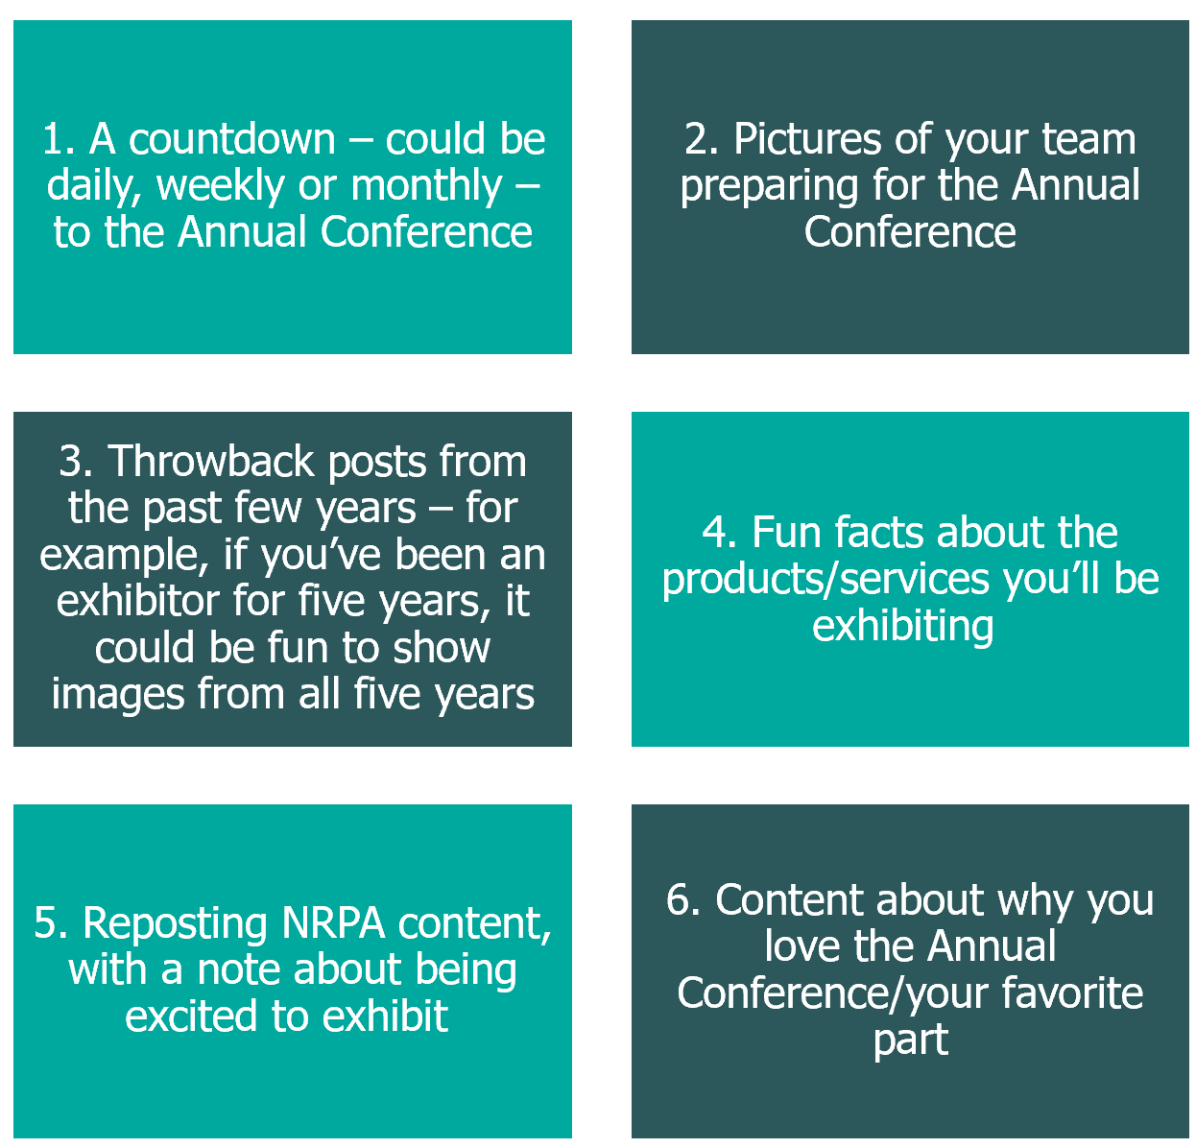

Social Media Videos
According to a study in the University of New Hampshire Inquiry Journal, “54 percent of consumers want to see video content from businesses and brands they support.” That means we all have a huge opportunity to reach our audiences with a medium they love! The good news is, you can easily create videos meant for social media on your phone. We’ve included ideal video length below:

Facebook | LinkedIn | Twitter | Instagram
1 minute or less | 30 seconds or less | 44 seconds | - 15 seconds for Instagram stories  - 1 minute or less for Instagram Reels

Ideas for videos include:

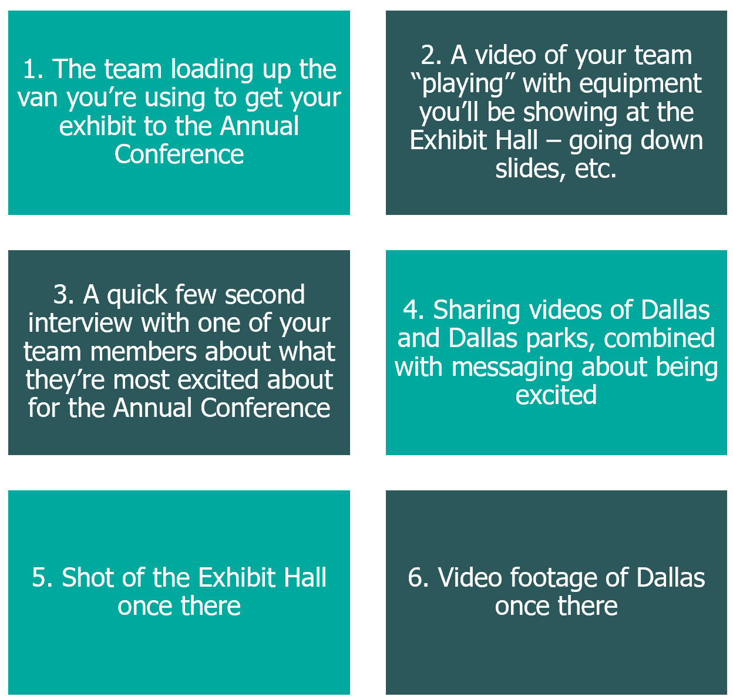

Graphics
Using graphics is an eye-catching way to market your exhibitor status! We’re including a few graphics that we invite you to use below.

Exhibitor Logo

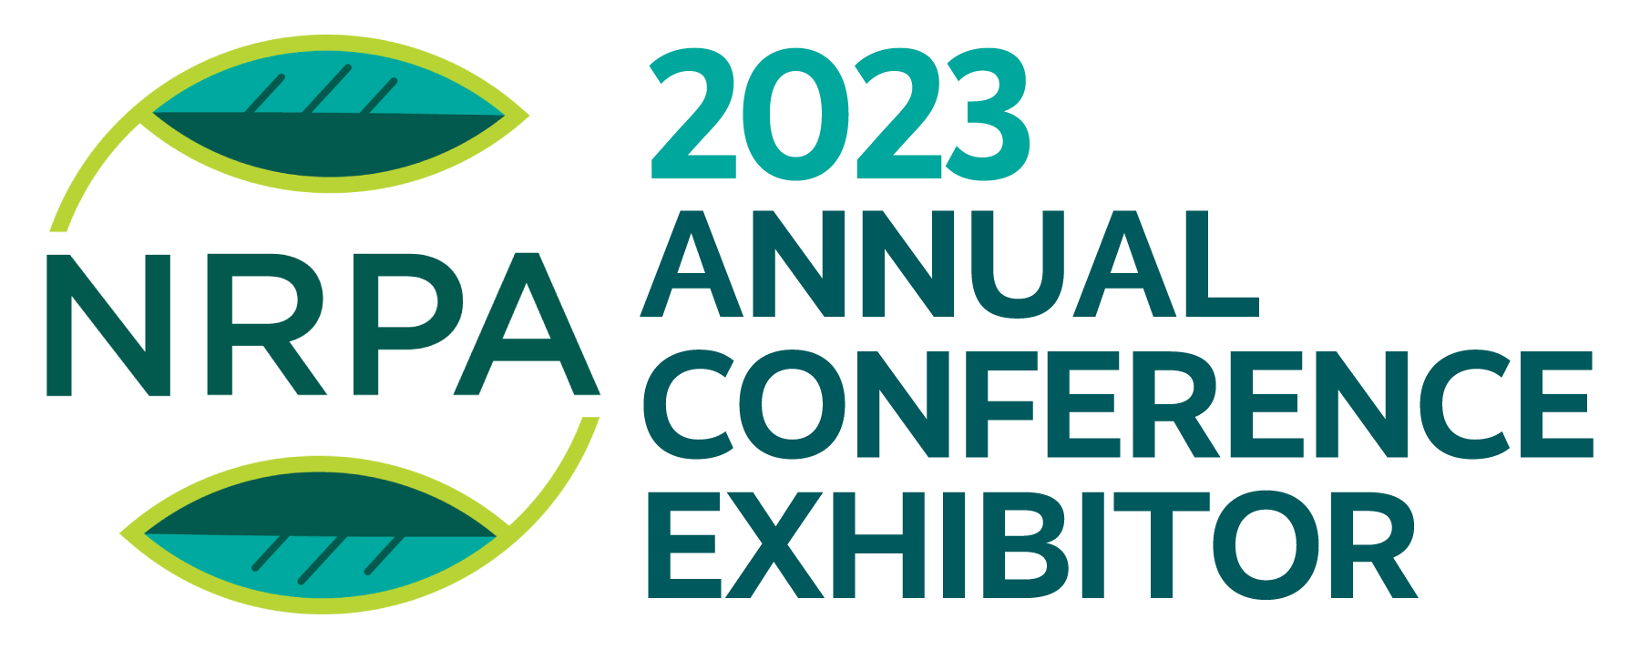

Find all the files here.

Exhibitor Social Media Graphic
We created four graphics to choose from that you are welcome to use on your social media handles. You can see them below! You can find them specifically sized for Facebook, Instagram, LinkedIn and Twitter if you click here.

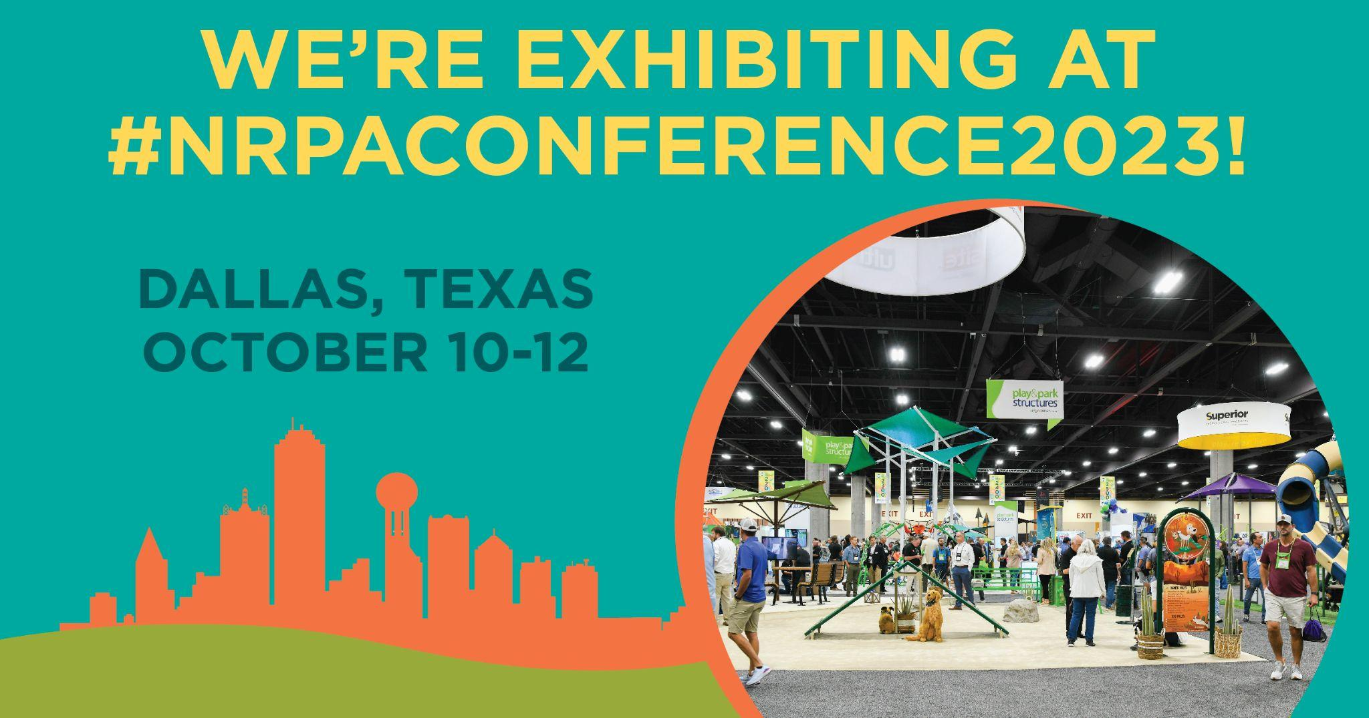 | 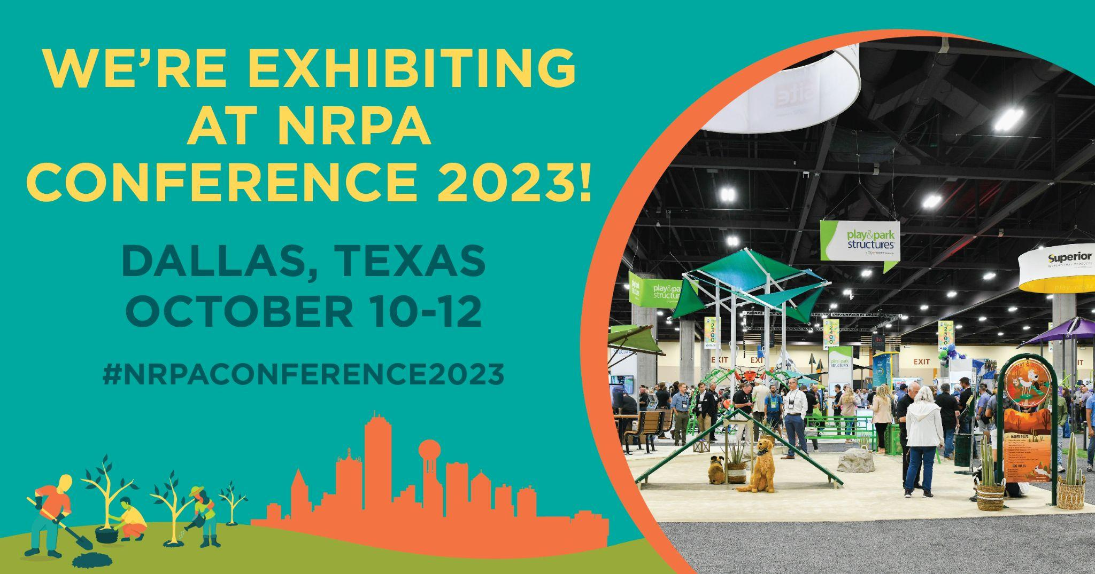
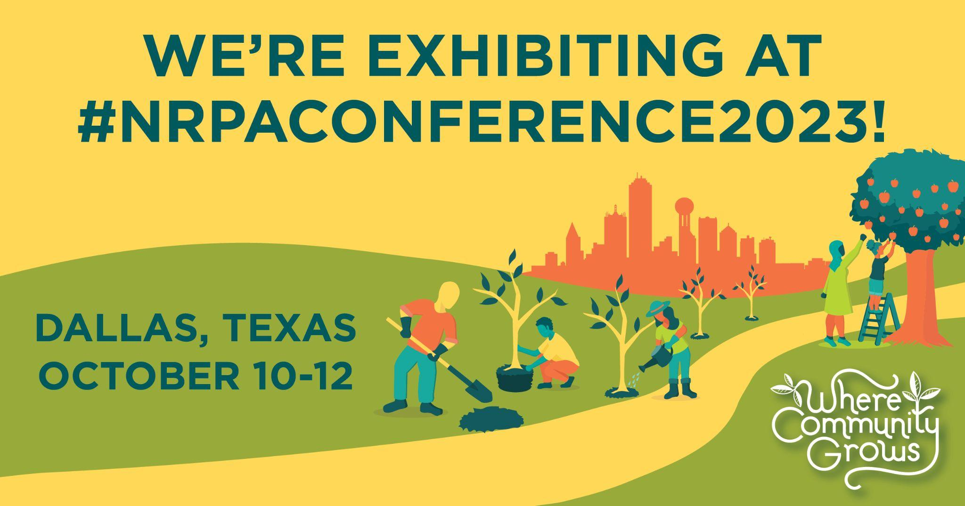 | 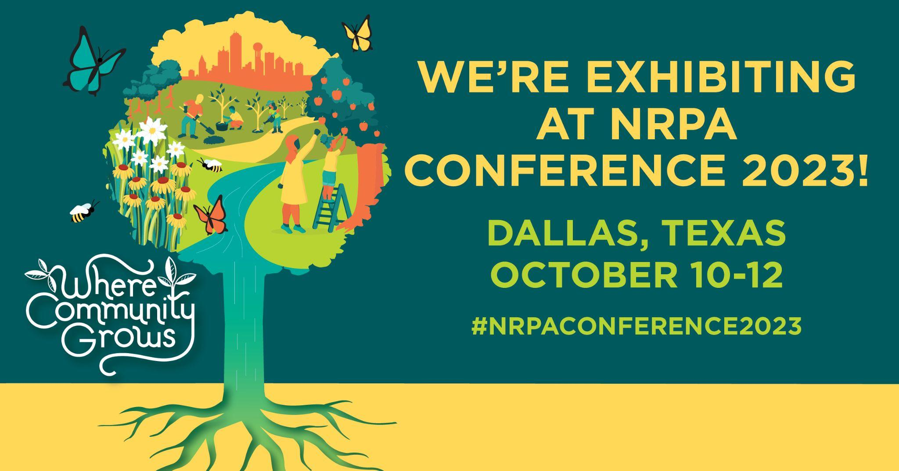

Find all the files here.

Email Graphics
We created six graphics you are welcome to use in both your email marketing and on your website. You can see the options below, as well as find all the files here.
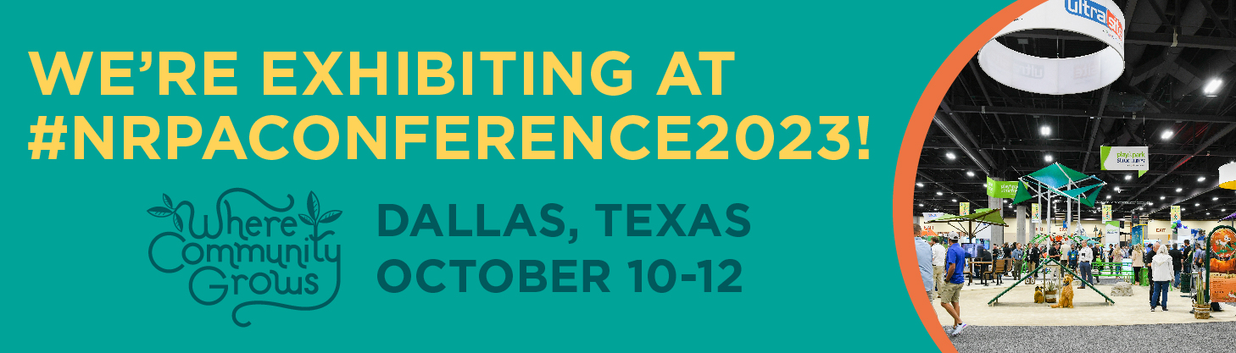
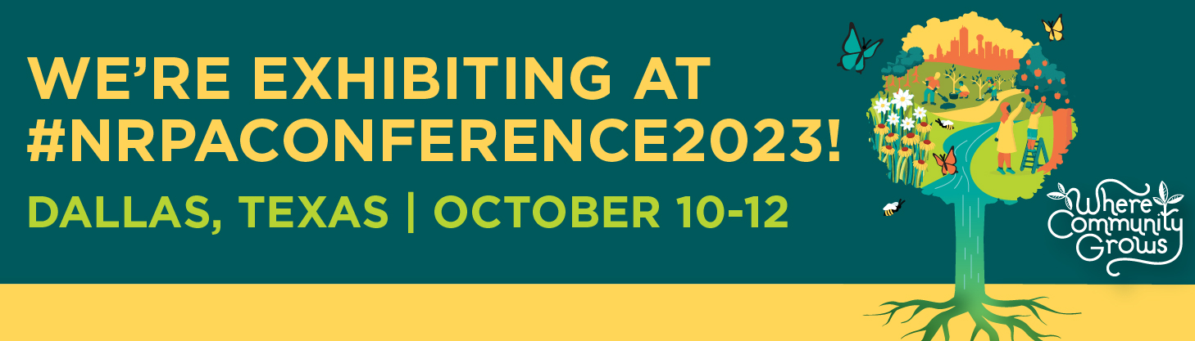

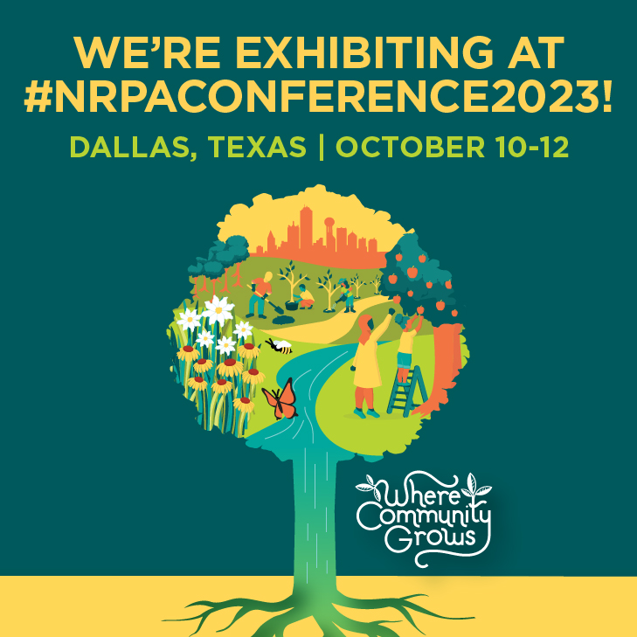 | 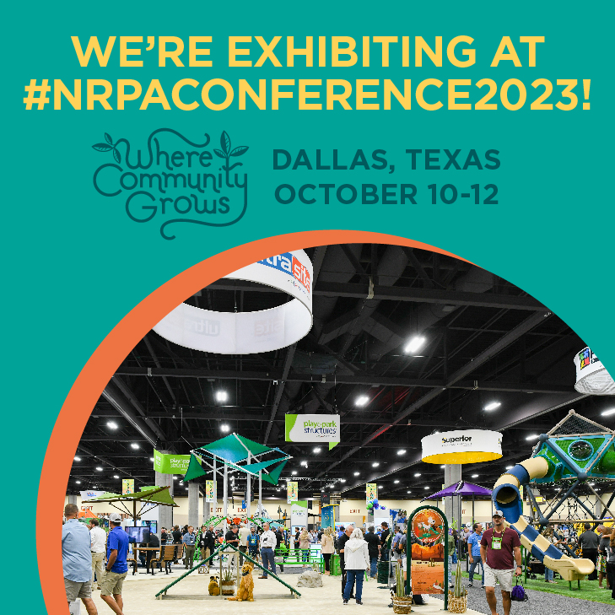
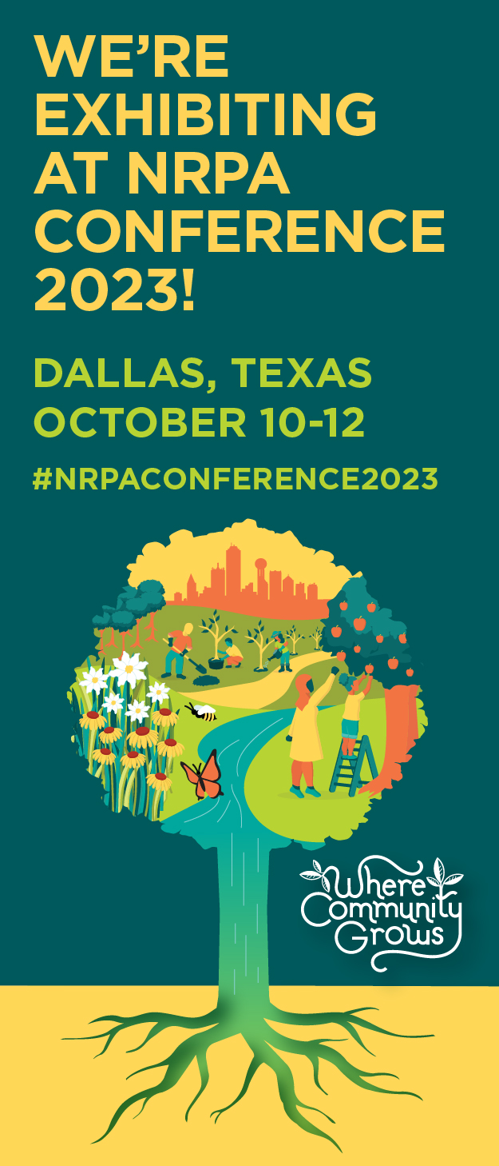 | 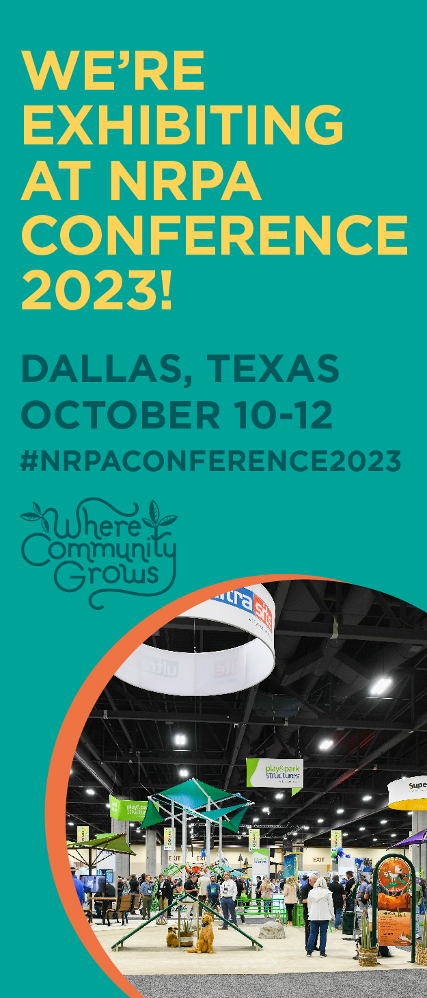

Find all the files here!

Social Media Best Practices
Each social media channel has its own quirks and strategy for what works best for it. We’ve summarized best practices for Facebook, LinkedIn, Twitter and Instagram below.

Social Media Account | Best Practices
Facebook | Best times to post: Mondays through Fridays at 3 a.m., Tuesdays at 10 a.m. and noon.
 | Worst times to post: Saturdays.
Best practices:
- Use 2-5 hashtags with each post.
- Always include an image or photo.
- Videos are a great way to increase engagement.
- Engage with your audience. “Like” and comment when they respond to your posts.
- Tag people and organizations (including NRPA!) to boost engagement.
LinkedIn | Best times to post: Tuesdays 10 a.m. to noon.
 | Worst times to post: Saturdays and Sundays.
Best practices:
- Use 2-5 hashtags with each post.
- Use a slightly more formal tone.
- Consider posting in LinkedIn groups.
- Tag people and organizations (including NRPA!) to boost engagement.
Twitter | Best time to post: Mondays, Tuesdays, Wednesdays, Fridays and Saturdays at 9 a.m.
 | Worst times to post: Sundays. However, day matters less on Twitter than it does on other platforms.
Best practices:
- Use 1-5 hashtags with each post.
- Use a shortened URL of your link, using a free tool like bit.ly.
- Ensure your post is 280 characters or less (including your link).
- Tag people and organizations (including NRPA!) to boost engagement.

Note: Twitter is changing every day. These are best practices from when we created this toolkit.
Instagram | Best time to post: Mondays at 11 a.m., Tuesdays and Wednesdays from 10 a.m. to 1 p.m., and Thursdays and Fridays 10 a.m. and 11 a.m.
 | Worst times to post: Sundays.
Best practices:
- Include photos (not just graphics) to build strong connections with your community.
- Use 1-5 hashtags with each post.
- Tag people and organizations (including NRPA!) to boost engagement.

Read more data about best and worst times to post here, and additional posting best practices here.

Newsletter and Website Content
We’ve included content below that you can drop into a newsletter or onto your website. Please update this messaging as you see fit! (You know your audiences the best.)

Text
Registration is open! Will we see you at this year’s NRPA Annual Conference?

At the 2023 NRPA Annual Conference, attendees will experience inspirational education sessions, networking opportunities, celebrations and – of course – an inside look at the latest products for our field.

Our team is excited to join colleagues, experts and friends in sunny Dallas on October 10-12. We hope you come by and meet us at the Exhibit Hall, where we’ll be INSERT WHAT YOU’LL BE EXHIBITING AND WHAT ATTENDEES CAN LEARN MORE ABOUT. We’re joining more than 400 partners and vendors who are setting up booths and interactive exhibits. Find us at booth INSERT BOOTH NUMBER.

We know that when we come together to network with, learn from and celebrate each other, we can truly build places Where Community Grows.

Register here to join us: https://www.mcisemi.com/nrpa2023/.

Media Relations Tips
Media relations is a great way to build excitement about an event such as the Annual Conference. The question is, what makes your role as an exhibitor newsworthy? We’ve included the six categories that most frequently make a story newsworthy below.

TIMELY  HOLIDAYS,  SPECIAL EVENTS, ETC. | SUPERLATIVE  FIRST, BEST, ONLY | PROXIMITY  LOCAL, HOMEGROWN | CONFLICT AND CONTROVERSY  TENSION, DEBATE, ADVOCACY, HIGHLIGHTING PROBLEMS OR DIFFERENCES WITHIN A COMMUNITY | HUMAN INTEREST  SOFT SIDE, GOOD NEWS, WARM AND FUZZIES | HELPFUL  TOP LISTS, BEST WAYS TO DO SOMETHING

For example, if you’re launching a new product at the NRPA Annual Conference, that would be superlative! If a family was able to compete in a wheelchair basketball league for the first time because of your equipment and a partnership with a local park and recreation center, that would be both human interest and superlative.

If you have a media relations idea, please reach out to Danielle Doll at ddoll@nrpa.org. We are happy to share best practices, support your team in pitching and work together to make sure the story is a success!

